SAFETY TOPIC: Landing With Wind!
Hello everyone! Welcome to springtime flying. Constantly changing temperatures and pressures mean the winds will be shifting all over the place for the foreseeable near future…are you proficient in strong, sometimes gusty, winds and crosswinds?
For you Columbus, Seymour, and North Vernon dwellers, it can get relatively easy for crosswind skills to degrade when the option to land on a more preferable runway exists! Now is the time to fly within your personal minimums, or take an instructor and get some practice in with less favorable conditions. Practicing landing in different conditions makes you a more adaptable and safe pilot all around.
Let’s review some techniques for when you’re flying on a less-than-ideal calm wind day!
For starters, especially for you lighter aircraft owners…remember your taxiing yoke positions! I always remember it as “turn into, dive away,” or if you’re a taildragger, “pull into, dive away.” Not only do you not want to get blown around any more than necessary on the ground, but strong gusts of wind can forcibly move the flight controls around and cause them to slam to the stops…not particularly something we want happening!
Remember that taxiing positions start as soon as you touch down and should be held as inputs until you lift off and crab as necessary! I cannot count the number of times students have not put full aileron into the wind after landing and we have almost flipped over!
When taking off with strong winds down the runway, it is often helpful to keep a slightly faster than normal climb speed to account for any airspeed variations that might occur as a result of the wind, as well as to avoid any increased chance of stalling due to increased loads during bumps of turbulence! Once you’re in the air and climbing out, remember to let the airplane crab into the wind to keep your climb path out over the runway to maintain the best guaranteed obstacle clearance possible.
In the pattern when winds exist, do not forget to crab! Something that can make this process a little easier is to get established on each leg and look straight out along that leg of the pattern. Choose a point off in the distance that would be a good indicator of if you’re drifting left or right of where you want to be, and use that to ensure you aren’t getting any side drift…if you are, crab more.
I have found, in my opinion, the worst conditions to be in are a left crosswind when landing because it puts a lot of wind behind you on the base leg and increases your groundspeed, not only decreasing your time to descend to an appropriate altitude, but if not careful pushing you way past the final approach course. In these conditions it is important to stay cognizant, and often a nearly constant downwind-base-final turn is necessary!
Finally, when you make it to that leg on final, remember the general rule of thumb for gusty winds is to add half of the gust factor to your final approach speed to obtain an amended approach speed that keeps you safe in the absence or addition of any wind. Generally, if it’s pretty gusty, I just add 5 knots. Also, it is often helpful in stronger winds to use a notch of flaps less than usual (if you have them). Sometimes in really windy conditions I have found full flaps (especially if they are 30/40 deg) greatly hinder your ability to smoothly cut through the wind.
When crosswind conditions exist, recall there are two primary methods for approaching to land:
The crab method: Crabbing on the approach is done the same way as any other crab, which is essentially shifting the alignment of the nose of the plane to avoid drifting left or right of centerline. The caveat being…you can’t land the plane sideways! So, once over the runway it becomes necessary to align the nose with the use of rudder and use aileron to maintain centerline, keeping ailerons down (turned) toward the wind. I find the crab method works better in stronger winds than the wing-low method.
The wing-low method (sideslipping): In lighter crosswinds you can often use a sideslip to keep your nose pointed straight down the runway for the entire approach. Using this method, use rudder to straighten the nose to the runway and then keep the upwind wing down into the wind by turning ailerons toward the side from which the crosswind is blowing. Once established, ailerons can be used to maintain centerline while rudder is used to maintain nose alignment. This method eliminates the need to “de-crab” when you come in to land.
Finally, remember that you can land on one wheel! Landing and rolling out on the upwind main gear is often necessary and should be done to mitigate skidding across the runway surface when landing in crosswinds!
There’s no better time than now to get out and have some *safe fun in the windy skies!
For more information check out this article (How To Make A Perfect Crosswind Landing | Boldmethod) or chapter 9 “Approaches and Landings” in the Airplane Flying Handbook.Any Questions?

CHAPTER NEWS:

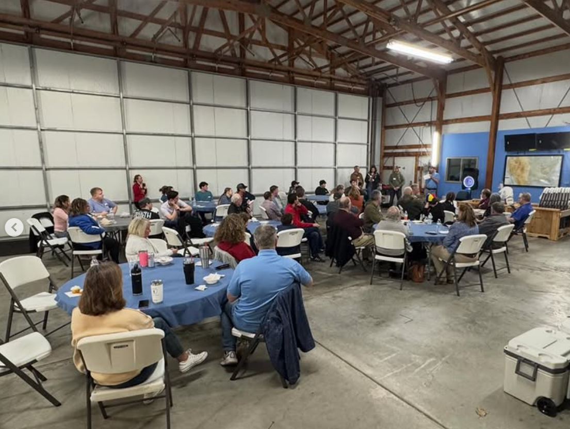
Chili Cookoff!
Thank you to everyone who came out to the Chili Cookoff last month. It is always a highly popular event with the chapter! We appreciate everyone who attended, brought food, and voted for their favorite chili. It is unknown if the winner, EAA President John Tunell, rigged the election or not, but we will send him congratulations regardless! Any complaints or requests for recounts can be submitted to me at cbuskate@gmail.com.
We recognized a few outstanding members of the chapter at this event:
Brad Stinebring for being a highly dedicated board member and for keeping this chapter afloat as president for many years, as well as serving many years on the board beyond that. Brad is still highly involved with the Youth Center and the Ray Scholarship program, and he keeps the hangar in one piece!
Brad Moore for being a valuable member of the board for so long. Brad put in countless hours getting the website and social media implemented and was a longtime Young Eagles Coordinator, building the Young Eagles program into what it is today.
Thank you, Brad and Brad, for your time on the board. You will be missed saying “Aye” at the table.
Young Eagles Impact Awards - Ryan and I (Kate) developed a new award for chapter members who go above and beyond by dedicating countless hours and resources to our Young Eagles Program. This award recognizes both ground and pilot volunteers:
Riley Scruggs, Eric Scheidt, Thomas Morone, Alvin Roesner, Paula Lynch
We also wanted to give Dave Lynch special recognition for being so heavily involved with the Young Eagles program and for being a dedicated volunteer within the Youth Center and beyond!
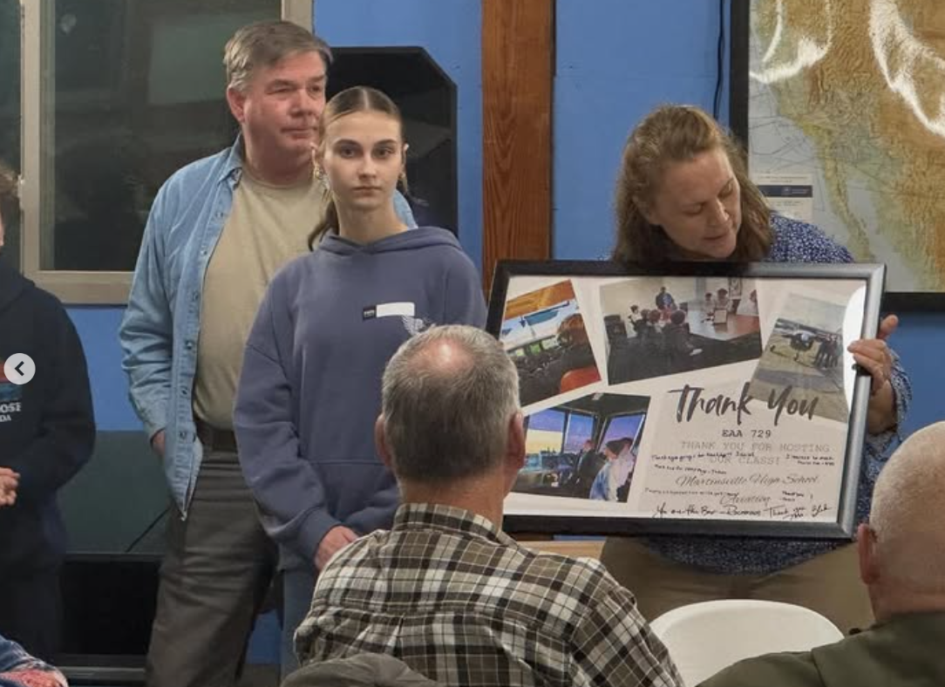
Thank you to all of these outstanding volunteers! This program is not possible without your help, and the work you are doing is truly life-changing.
Additionally, Teacher and Program Director Sheila Blake shared recognition from the Martinsville High School Aviation Program for our chapter’s support.
The event did come to an abrupt end due to the Monroe County EF-2 tornado. Not sure who we let decide the event was still safe given the imminent threats; however, they clearly need to work on their forecasting skills. To quote Jason Teepool: “Kate needs to go back to school…do not let her graduate yet.”

Youth and Adult Build Updates
Youth Zenith 650 Build Progress
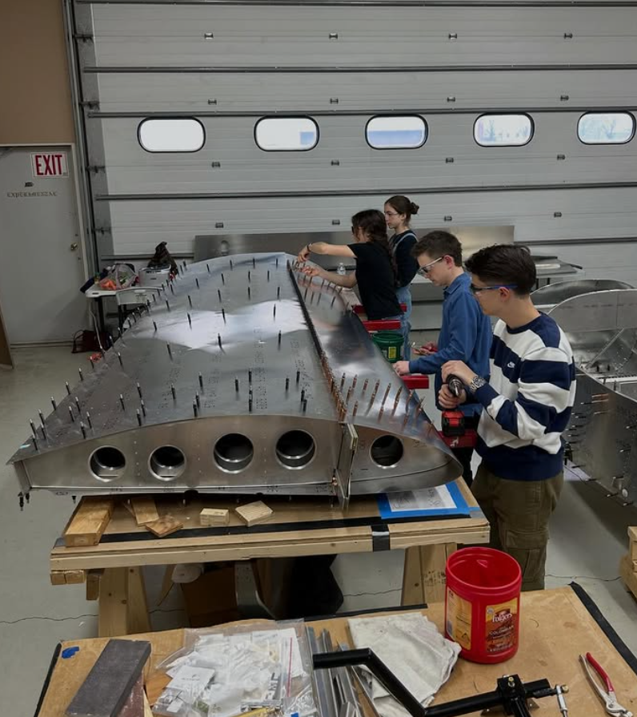
The youth have been hard at work correcting the wing leading edge that was originally misdrilled. The new parts have arrived, and progress has been made to bring this wing back up to pace! Next, they will begin work on the fuel tanks and fuel system.
We continue to have a great group of engaged students, and attendance has recently been overwhelming in the best way possible. It’s exciting to see so many young people getting involved with aviation in such a meaningful way. The students have also been tasked with developing paint scheme ideas for the Zenith, and we hope to reveal those soon for comments and feedback.
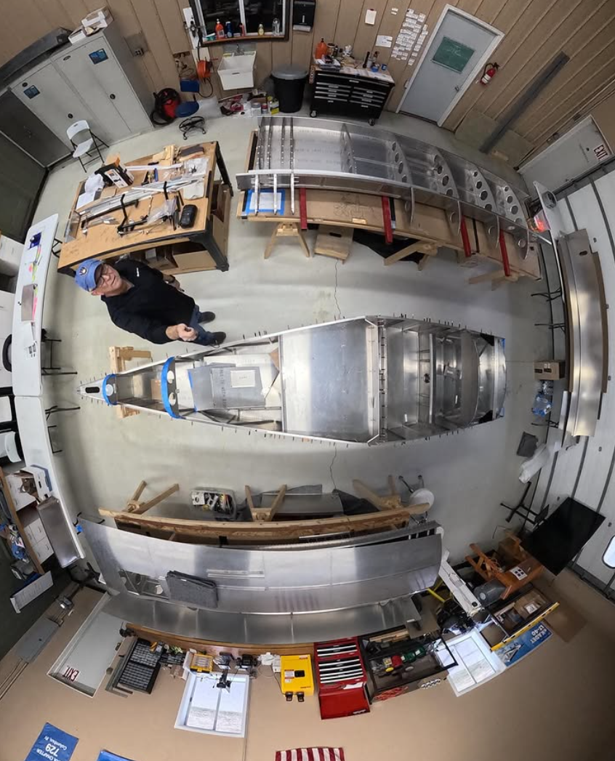
With the high turnout and a slightly slower phase of the build at the moment, students have also continued taking field trips over to Mike William’s shop and have been helping Brad Stinebring with work on his N3N. We all knew it was only a matter of time before Brad began using the students for his own good!
Adult Zenith Build Sessions
The adult crew has begun riveting the fuselage structure together and installing the primary flight controls, marking an exciting step as the aircraft starts to take on its full form. This phase brings together many of the components that have been prepared over the past several months and represents real visible progress in the build. Next, the team will move on to fitting the landing gear and installing the turtle deck
Additionally, the engine and firewall-forward kit has officially been ordered from Zenith!
For real-time updates and behind-the-scenes moments from both build projects, follow us on Facebook at facebook.com/eaa729 and on Instagram at instagram.com/eaachapter729.

Volunteer Opportunity: Help with Youth Zenith 650 Build
We are looking for volunteers with mechanical aptitude and a passion for aviation to help mentor the next generation of aviation enthusiasts as they build a Zenith 650! If you have experience in aircraft construction, mechanics, or simply enjoy working with young people in the aviation community, we would love to have you on board. This is a fantastic opportunity to share your knowledge, inspire future pilots, and make a lasting impact on the lives of these young builders. If you’re interested in volunteering, please reach out directly to Brad Stinebring or James Yrineo for more details.

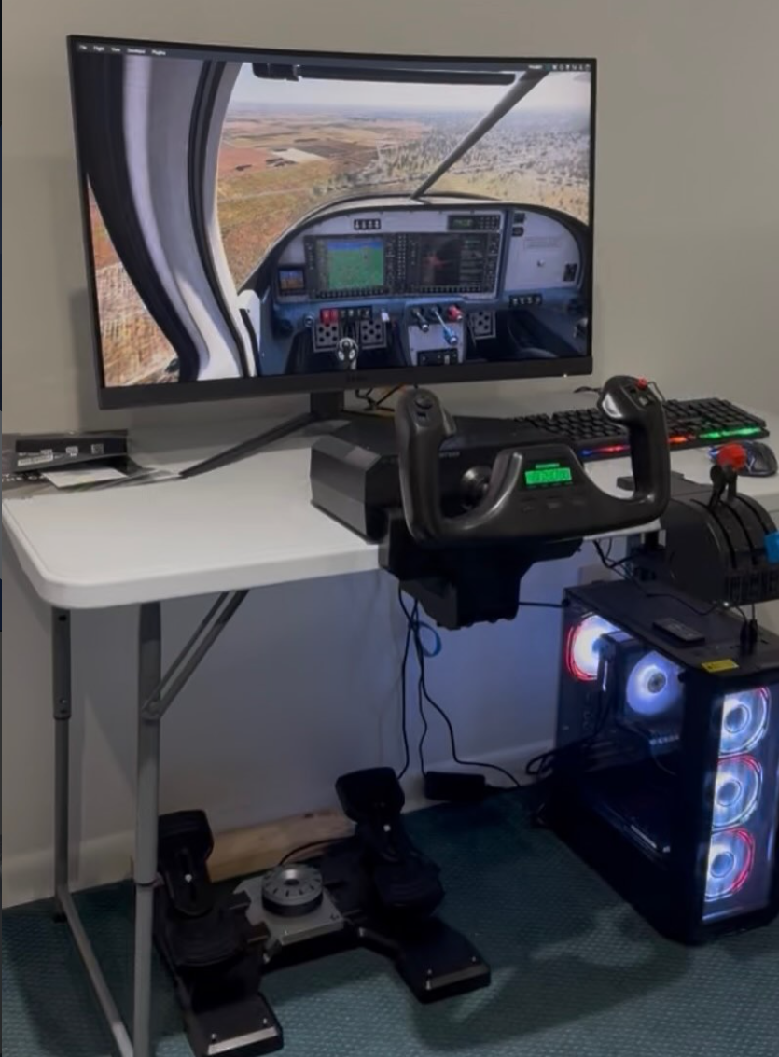
New Simulator
Thanks to a generous donation, we have a new addition to our Chapter 729 Aviation Education Center! We now have a gaming system set up with X-Plane12. This expands our capabilities beyond the RedBird TD BATD. The RedBird is an FAA Certified flight training device which allows CFIs and students to train and log hours. In addition IFR Rated pilots can log their 6HITS for maintaining currency. The X-Plane12 setup allows us to introduce non-training students to pilot principles, fly any number of aircraft configurations, and just have fun!
Reminder that students can gain access to the SIMs through their annual $20 chapter membership student/sim fee. Adult members can have access through their annual chapter $20 membership renewal and a $20 SIM fee. These fees go towards a maintenance escrow for the units!
I heard that anyone can get in and pretend to be a part of the elite Sonex Mafia…

Member Minute: Dean Rainbolt
Congratulations to chapter member Dean Rainbolt! Dean (on the right) received his airworthiness certificate on his Zenith 750 Cruiser. Some quick specs…
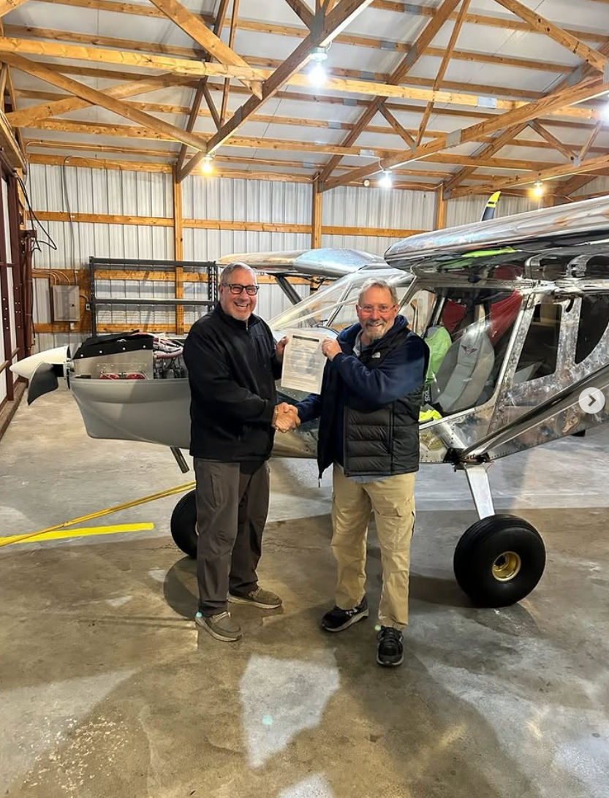
Zenith Cruzer with 21” tires:
- Project time- 4 years 5 months and 5 days. From the rudder built at the factory to the airworthiness certificate date.
- Actual build hours: 780 (97.5 days)
- Empty weight: 844 lbs
- 596lbs useful load (1440 max.)
We look forward to hearing his Phase 1 flight testing experiences!

Exciting New Option: Lifetime Membership
We’re thrilled to announce a new opportunity for Chapter 729 members—a Lifetime Membership for a one-time investment of $500. This isn’t just a membership upgrade; it’s a smart investment that benefits both you and the chapter for years to come.
When you purchase a lifetime membership, the full $500 goes directly into the EAA Chapter 729 Heritage Fund. The Heritage Fund returns approximately 4-5% of the principal to EAA 729 annually (roughly equivalent to typical yearly dues). The remaining interest is folded back into the fund, allowing your investment to grow over time.
What’s Included:
- Lifetime chapter membership dues (no more annual renewals!)
- Your contribution grows in the Heritage Fund
- The chapter receives ongoing annual support from your investment
- (top secret information but I have heard rumors of a complimentary T-shirt)
*Important Note: The lifetime membership covers chapter dues only and does not include simulator access. Lifetime members who wish to use the simulator will still need to purchase the annual simulator membership separately.
The lifetime membership option will be available on our website at https://eaa729.org/shop/ …soon.
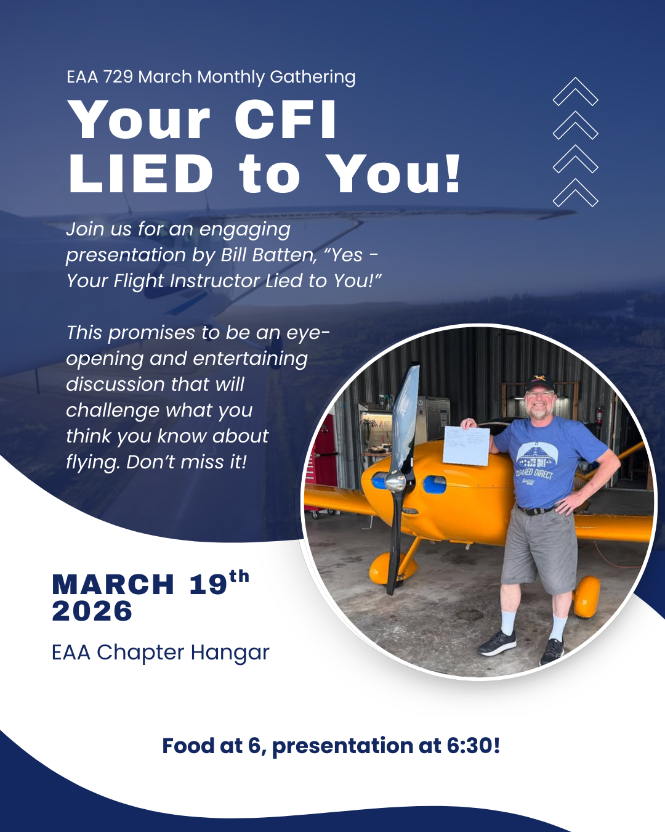
Have questions about the Heritage Fund and how it works? Reach out to Bill Batten, John Tunell, or Brad Stinebring for more information.

REMINDERS:

Upcoming Chapter Events and Gatherings
March Monthly Gathering
Thursday, March 19th at 6:00 PM
EAA Chapter 729 Hangar – KBAK
Join us for our March gathering featuring a presentation by Bill Batten titled “Yes - Your Flight Instructor Lied to You!” This promises to be an eye-opening and entertaining discussion that will challenge what you think you know about flying. Don’t miss it!
April Work Day
Saturday, April 18th at 9:00am
EAA Chapter 729 Hangar – KBAK
Join us for our annual hangar clean-up and work day! We’ll kick things off with a pancake breakfast, then roll up our sleeves and tackle a few projects around the hangar to get everything ready before summer arrives. It’s a great chance to help out, spend some time around the airplanes, and enjoy the camaraderie of fellow members. We appreciate everyone who lends a hand and look forward to a great morning of spring cleaning together!

2026 Young Eagles Schedule
2026 Young Eagles Rally dates:
- May 9, 2026
- June 13, 2026
- August 8, 2026
- September 19, 2026
- October 17 (tbd)
Each rally runs from 9:00 AM to 1:00 PM, with registration opening one month prior to each event. Flight reservations can be made at http://eaachapters.org. Follow the calendar at eaa729.org and our social media (@eaachapter729 on Facebook and Instagram) for updates!

If you are interested in volunteering with the Young Eagles Program either as a pilot or ground volunteer, please visit Young Eagles Resources for Chapters and Volunteer Pilots| EAA AirVenture Oshkosh for more information and contact Ryan Malanoski rkmalanoski@gmail.com to get started!

Friendly Reminder: 2026 Chapter Dues
As we continue through another exciting year, we kindly remind all EAA 729 members to submit their 2026 chapter dues. Your continued support helps cover essential expenses like hangar maintenance and the food we all enjoy during our gatherings. Every dollar you contribute goes directly back into benefiting the chapter and its members.
Not sure of your current status? Reach out to Bill Batten, he will be happy to help. Thank you for being a vital part of our aviation family!

Submit Your Accomplishments and Updates!
We want to hear from you! Chapter 729 is always looking for member-contributed content to feature in our monthly newsletter. Whether you’ve achieved a new rating, reached a building milestone, completed an interesting flight, or have an aviation story to share, we’d love to include it.
We’re looking for aviation achievements and milestones, personal aircraft build project updates, interesting flying experiences or trips, aviation-related articles or insights, and photos from your aviation adventures.
How to Submit: Send your stories, articles, or photos to John Tunell at jtunell.av8r@gmail.com. Help us celebrate the diverse aviation experiences within our chapter community!

CONTACTS/LINKS/SCHOLARSHIPS/ETC.:
Website: eaa729.org
Facebook: facebook.com/eaa729
Instagram: instagram.com/eaachapter729.

Board + Committee Contacts

John Tunell (President) - jtunell.av8r@gmail.com
Kate Russell (Vice President) - cbuskate@gmail.com
Bill Batten (Treasurer) - williamabatten@gmail.com
Larry Kelly (Secretary) - lostaviator@gmail.com
Ryan Malanoski (Y.E. Coordinator) - rkmalanoski@gmail.com
James Yrineo - jfyrineo@gmail.com
Kyle Smith - mister.meow@icloud.com
Jason Tepool - jasontepool@gmail.com
Noah Shatto - gonefishingaway@gmail.com
Dan Villiger - dan.villiger@sbcglobal.net
Mike Foushee - michaelfoushee@yahoo.com
Brad Stinebring - blstinebring@comcast.net

EAA & AOPA Airshow Schedules
AOPA Events - https://www.aopa.org/news-and-media/news-by-topic/events/airshow
EAA Events - https://www.eaa.org/eaa/events
Scholarships
Opportunities
The Columbus Municipal airport is accepting applications for their summer internships! Applications Close May 13th.
https://cityofcolumbusin.munisselfservice.com/ess/EmploymentOpportunities/ApplicationEntry.aspx?form=1000&req=2894&sreq=1&desc=AIRPORT%20MAINTENANCE%20INTERNSHIP

https://cityofcolumbusin.munisselfservice.com/ess/EmploymentOpportunities/JobDetail.aspx?req=2894&sreq=1&form=1000&desc=AIRPORT%20MAINTENANCE%20INTERNSHIP

https://cityofcolumbusin.munisselfservice.com/ess/EmploymentOpportunities/ApplicationEntry.aspx?form=1000&req=2895&sreq=1&desc=AIRPORT%20ADMINISTRATION%20INTERNSHIP

https://cityofcolumbusin.munisselfservice.com/ess/EmploymentOpportunities/JobDetail.aspx?req=2895&sreq=1&form=1000&desc=AIRPORT%20ADMINISTRATION%20INTERNSHIP

