SAFETY TOPIC: Warm Weather Flying
Happy Summer, Everyone!
As temperatures rise, it's a great time to review a few considerations for safe summer flying. Hot weather affects not only pilot comfort, but also aircraft and engine performance.
Hot Temperatures = Hot Engines
Engine cooling becomes more critical during the summer months. High outside air temperatures reduce cooling efficiency, especially during extended taxi operations and climbs. Consider using a slightly lower climb rate when practical to increase airflow through the engine compartment and help manage cylinder head and oil temperatures.
Remember Density Altitude
High temperatures can dramatically increase density altitude, reducing aircraft performance. Expect longer takeoff rolls, reduced climb rates, and degraded overall performance. Even airports at relatively low elevations can experience surprisingly high density altitudes on hot afternoons. Take the time to calculate performance before departure and ensure your aircraft can safely meet the required takeoff and climb performance. "It'll probably make it" is never a performance calculation. And for the record…no, your 70 year old airplane proobbbbably isn’t getting the best PoH suggested performance after all this time. If you are pushing it, consider taking less fuel or departing at a more favorable part of the day!
Review Hot Start Procedures
Every aircraft and engine combination can behave differently when hot. Take a few minutes to review the hot start procedures in your POH before you need them. Following the manufacturer's recommended procedures can save time and reduce starter wear
Stay Hydrated
Heat affects pilots just as much as airplanes. Dehydration and fatigue can impair overall performance. Bring water to stay hydrated throughout the day, and recognize when the heat may be affecting your decision-making.
Preflight Carefully
Metal surfaces, oil caps, fuel caps, seatbelt buckles, and cockpit interiors can become extremely hot after sitting in the sun. Use caution during preflight inspections and take a moment to verify everything is properly secured before departure-regardless of how quickly you'd like to get back into the air with the air flowing!
Fly safe, stay cool, and enjoy the summer flying season!

Freeman Flying Field Visit!
Thank you to those who visited the Freeman Flying Field last month! Special thanks to chapter member Larry Bothe for hosting everyone!
For those who were unable to attend, here is Larry’s telling of a stand out story regarding a * previously hosted piece in the museum…
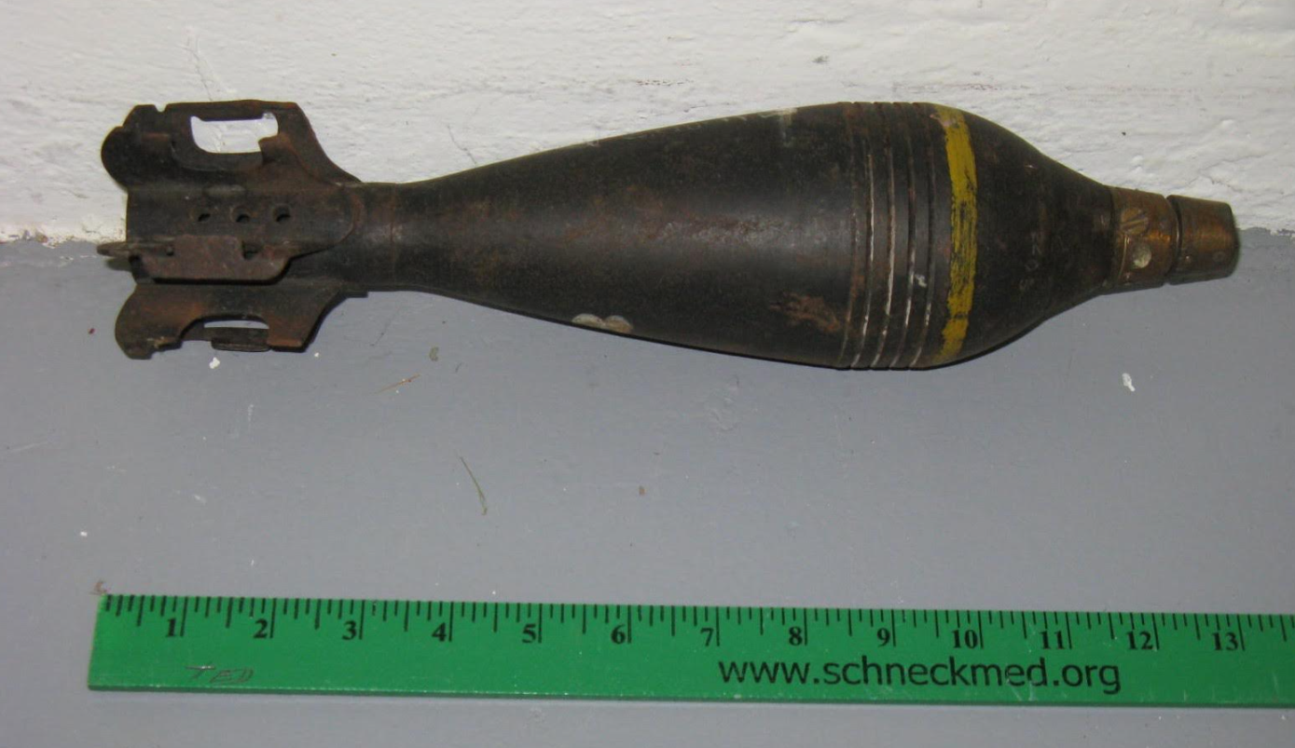
“About 15 years ago I got a call from the guy who ran the Naval Ordinance Museum near St. Louis. He was going to be in the Seymour area and wanted to see the museum. This was before the building we now call our Annex was very well organized. There were some unidentified items just laying around. One such item was a mortar round, laying on a wooden picnic table. The NOM guy asked about it. My reply was that I didn't know very much. It had been in the museum, and moved many times, as long as I had been there (since 2002). It was sort of an orphan; I had nothing related to go with it. He picked it up and looked at it. After a few minutes of examination he layed it down very carefully, and told me he believed it was a live round. Since mortars explode on impact, dropping it would be really bad. Oh, sh*t! He pulled out his cell phone and called somebody he knew at Crane Naval Weapons. The call went to voice mail, and he told the guy what he had found, and gave him my name and cell phone number.
Later that day my phone rang; it was the Crane guy. He wanted to know if I could take a picture of the mortar round, and send it to him right away. I did. The next morning around 8:00, while I was having morning coffee (I was retired, even back then), my phone rang. The Crane guy again. He wanted to know if he could come to the museum. I ask when. He said, "We're already on the road, we'll be there in about an hour." Oh! I got dressed and went to the museum. Soon he and 2 other guys showed up in a big GMC SUV. Looked like something the Secret Service would run around in. They had computers, scales, and other test instruments that I didn't recognize. They set up shop on the picnic table. After about an hour they called me over and announced that they were 95% sure the round was indeed live.
What now? They wanted to know if I was in love with the mortar round, because it would need to be destroyed. I respond that if I was ever in love with it, that infatuation had quickly faded away. I stated what I was pretty sure was the obvious; "OK then, you'll take it back to Crane and make it go away?" "Hell no, we're not putting that thing in our vehicle. It's unstable. We'll just blow it up here." Say what? Yeah, sure. There must be some place we can do it. Call the police. OK, I knew the Chief; I called. Nope. They didn't have a place. They wouldn't let us use their shooting range (right on the airfield). Darn. The police told us to call the airport manager. At the time that was Don Furlow. We didn't call; we just went to his office; only about 2 blocks from the museum.
All four of us traipsed into Don's office. He knew immediately this couldn't be good. We told him we wanted to blow up a mortar round at the airport. He says, "Heck no, call the police." We burst out laughing, and told Don the police told us to call him. Don realized we were serious about this, and called the head of the Airport Authority. They decided we could blow it up out among the huge piles of wood ships that had accumulated on the west side of the airfield.
By this time it had started raining. Our little caravan of 3 vehicles drove across the airfield to the wood chip piles. The Crane guys opened their SUV and got out a brick of plastique explosive. One guy wrapped the plastique around the mortar round, and stuck a detonator in it. Another guy ran about 150 feet of wire around the wood chip pile to where we had parked the vehicles. The wires were connected to the detonator, and we retreated to the vehicles. An actuator was hooked up to the other end of the wires. The one Crane guy handed me the actuator, and said, "Here, it's your mortar round; you blow it up." I pushed the plunger. There was a loud bang (but no big explosion), and some wood chips flew up in the air. We went around to where a mortar round had been placed. Just a small crater in the wood chips. Nothing left; not even a fragment. The Crane guy rolled up the detonator wire, and we got in our cars and drove away in light rain.
One of the pictures I took to send to Crane is attached. The identification of the item came later, but that's the original picture of the mortar round in our museum.”
Larry Bothe, 812-521-7400 (cell)
Curator, Freeman Army Airfield Museum

Youth and Adult Build Updates
Youth Zenith 650 Build Progress
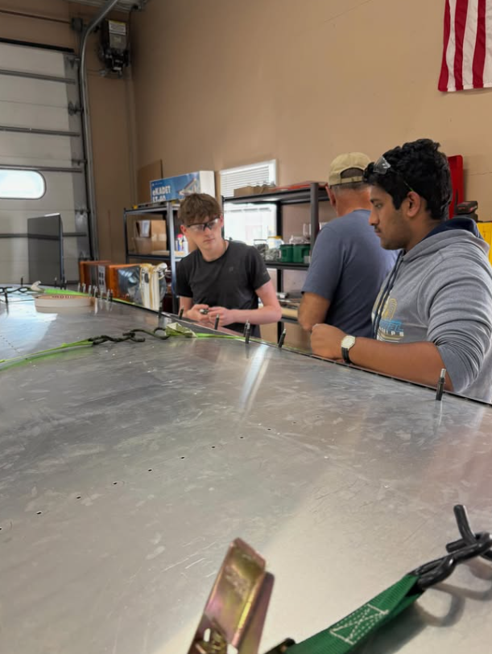
The Aviation Youth Center's summer student meetings began on June 3 and will continue every Wednesday from 1-5pm throughout the summer. The first meeting saw strong participation, with five students attending and engaging in program activities. Snacks and drinks were provided for both students and mentors.
One highlight of the meeting was the selection of a paint scheme for the Zenith project. Students and mentors voted on several submissions, ultimately choosing the "Hoosier Spirit" design created by Logan Maqueda. The voting process generated enthusiastic participation, with every submitted design receiving support.
The center has also begun an in-house overhaul of a donated Continental C-85 engine. Disassembly is underway, and the completed engine may be sold to help support program activities!
Adult Zenith Build Sessions
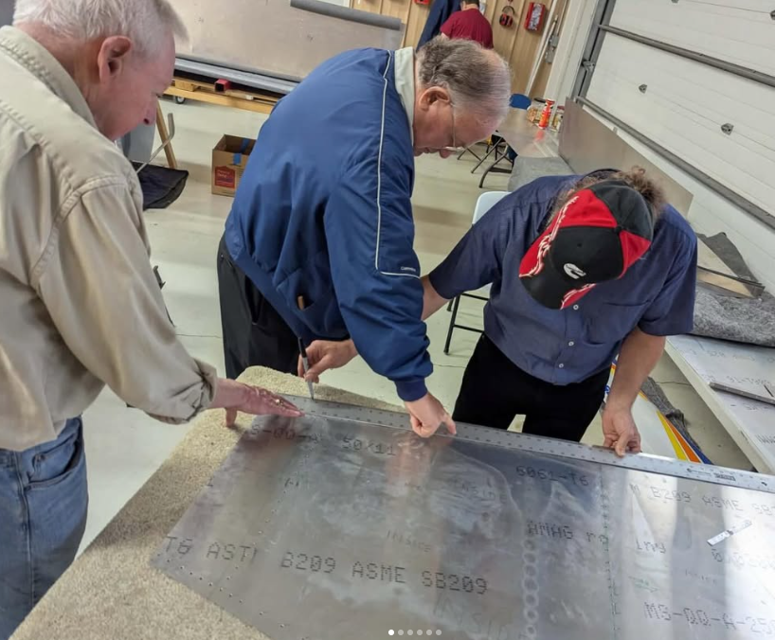
The Adult Build Team continues to make steady progress on the Zenith project. Recently, the firewall-forward kit, which includes the aircraft's engine, arrived at the chapter. Following inventory, a few components were found to be missing, a common occurrence with kit aircraft projects, and the team is currently working with Zenith to resolve the shortages.
During a recent build session, volunteers split into two groups to tackle key tasks. One team marked and trimmed the aircraft's top skin, while the other fabricated a skin doubler to relocate the flap tube pass-through hole.
For real-time updates and behind-the-scenes moments from both build projects, follow us on Facebook at facebook.com/eaa729 and on Instagram at instagram.com/eaachapter729.

Volunteer Opportunity: Help with Youth Zenith 650 Build
We are looking for volunteers with mechanical aptitude and a passion for aviation to help mentor the next generation of aviation enthusiasts as they build a Zenith 650! If you have experience in aircraft construction, mechanics, or simply enjoy working with young people in the aviation community, we would love to have you on board. This is a fantastic opportunity to share your knowledge, inspire future pilots, and make a lasting impact on the lives of these young builders. If you’re interested in volunteering, please reach out directly to Brad Stinebring or James Yrineo for more details.

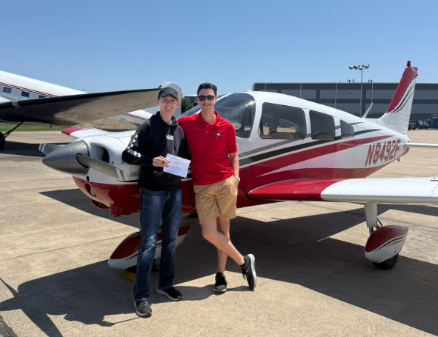
Member Minute: Matthew Degner
This March, Matthew Degner started a new role as a CFI/CFII at Hulman Field (KHUF) with Hoosier Aviation in Terre Haute, Indiana. Matthew grew up in Columbus, graduating from Columbus East High School and completing his PPL at BAK the summer after his senior year. He continued his flight training and academic education at Lewis University in Chicago, completing his IRA, CSEL, and CMEL with Lewis. He got his CFI and CFII in September of 2025 and graduated with a Bachelor of Science in December of 2025. A few weeks ago, Matthew also had his first successful checkride sign-off for an instrument rating!
Matthew has flown into OshKosh 3-ish times…one unfortunate send over to Fon-Du-Lac…and is looking forward to being more involved with the chapter in months to come.
For those of you unfamiliar with KHUF; Hulman Airport in Terre Haute has 4 runways, one set nine thousand feet and one set seven thousand feet. This is primarily due to its military use history, with the old airbase. Additionally, located on the field, is The Corsair Cafe. Recently under new ownership, I can give nothing but my highest recommendation. Visit their facebook (@CorsairCafe&Coffee) to see their daily specials and operational schedule.

Olney-Noble Fly-In
Many Chapter members recently embarked to the Olney-Noble Fly-In at KOLY under the flightname “Pancake 1”! We enjoyed donuts, aviation shaped pancakes, sausages, and drinks from the local EAA chapter there.
Shoutout to the Pancake Flight (+Syrup 1):
Roy Farris/Halle Friedan
Dan Villager
James Yrineo
Matthew Degner/Kate Russell

James was so cool as to document the experience! The video can be viewed at this link: https://youtu.be/oMOUddljpFs?si=n11zMdsF342TYC8k
Here are some photos otherwise…\
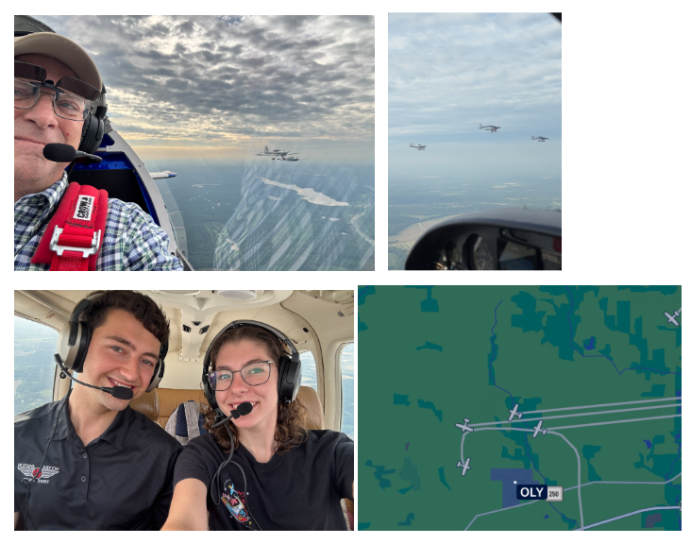

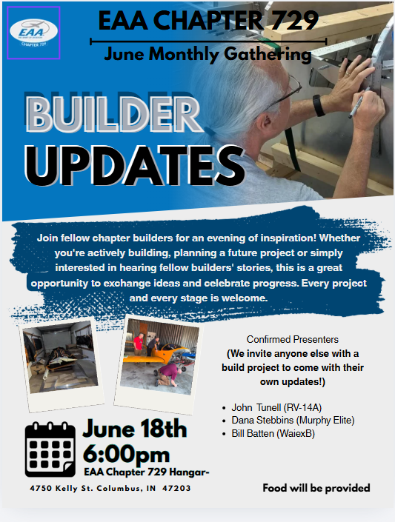
REMINDERS:

Upcoming Chapter Events and Gatherings
June Monthly Gathering
Thursday, June 18th at 6:30 PM
EAA 729 Hangar - 4750 Kelly St Columbus, IN 47203
The June Monthly Meeting Focus will be an annual “Builder Updates” event where we will meet to discuss many of our builders' progress and offer insight or just moral support!
THERE IS NO JULY MONTHLY GATHERING
GO TO OSHKOSH!
EAA Airventure (OshKosh) will be from July 20-26 and we hope to see you there! If you would like to receive EAA Chapter 729 OshKosh updates regarding group activities people may be doing fill out this survey with your email and phone number!
For more information…see the Official EAA Website
EAA AirVenture Oshkosh | Oshkosh Air Show | Oshkosh, WI

2026 Young Eagles
May 9th Young Eagles:
Thank you to all the ground volunteers, pilots, and young eagles who assisted with our first, successful, Young Eagles Rally of the year! We flew 52 Young Eagles at this event!
Special thanks to Eric Scheidt for flying the most Young Eagles at a whopping 12 EVEN after a getting a late start due to some clouds in the morning
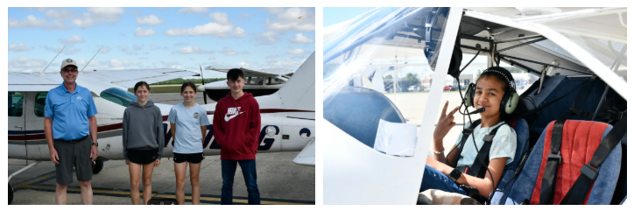
2026 Young Eagles Rally dates:
- May 9, 2026
- June 13, 2026 << NEXT UPCOMING RALLY
- August 8, 2026
- September 19, 2026
- October 17 (tbd)
Each rally runs from 9:00 AM to 1:00 PM, with registration opening one month prior to each event. Flight reservations can be made at http://eaachapters.org. Follow the calendar at eaa729.org and our social media (@eaachapter729 on Facebook and Instagram) for updates!

If you are interested in volunteering with the Young Eagles Program either as a pilot or ground volunteer, please visit Young Eagles Resources for Chapters and Volunteer Pilots| EAA AirVenture Oshkosh for more information and contact Ryan Malanoski rkmalanoski@gmail.com to get started!

Friendly Reminder: 2026 Chapter Dues

As we continue through another exciting year, we kindly remind all EAA 729 members to submit their 2026 chapter dues. Your continued support helps cover essential expenses like hangar maintenance and the food we all enjoy during our gatherings. Every dollar you contribute goes directly back into benefiting the chapter and its members.
Not sure of your current status? Reach out to Bill Batten, he will be happy to help. Thank you for being a vital part of our aviation family!
Special Recognition for new lifetime member John Lane! If you are interested in becoming an EAA 729 Lifetime member, visit https://eaa729.org/shop/ and select “Lifetime Membership”

Submit Your Accomplishments and Updates!
We want to hear from you! Chapter 729 is always looking for member-contributed content to feature in our monthly newsletter. Whether you’ve achieved a new rating, reached a building milestone, completed an interesting flight, or have an aviation story to share, we’d love to include it.
We’re looking for aviation achievements and milestones, personal aircraft build project updates, interesting flying experiences or trips, aviation-related articles or insights, and photos from your aviation adventures.
How to Submit: Send your stories, articles, or photos to John Tunell at jtunell.av8r@gmail.com. Help us celebrate the diverse aviation experiences within our chapter community!

CONTACTS/LINKS/SCHOLARSHIPS/ETC.:
Website: eaa729.org
Facebook: facebook.com/eaa729
Instagram: instagram.com/eaachapter729.

Board Contacts
John Tunell (President) - jtunell.av8r@gmail.com
Kate Russell (Vice President) - cbuskate@gmail.com
Bill Batten (Treasurer) - williamabatten@gmail.com
Larry Kelly (Secretary) - lostaviator@gmail.com
Ryan Malanoski (Y.E. Coordinator) - rkmalanoski@gmail.com
James Yrineo - jfyrineo@gmail.com
Kyle Smith - mister.meow@icloud.com
Jason Tepool - jasontepool@gmail.com
Noah Shatto - gonefishingaway@gmail.com
Dan Villiger - dan.villiger@sbcglobal.net
Mike Foushee - michaelfoushee@yahoo.com
Brad Stinebring - blstinebring@comcast.net

Committee Chairs/Contacts
Building Maintenance – Brad Stinebring
Young Eagles – Ryan Malanoski / Kate Russell
Website / Marketing – John Tunell / Kate Russell
Tool Crib – Larry Kelly
Youth Programs – Brad Stinebring
Aircraft Build – James Yrineo / Jason Tepool
Flight Simulator - James Yrineo, Ryan Malanoski, and Kyle Smith
Newsletter – John Tunell / Kate Russell
Ray Scholar – Brad Stinebring / Kate Russell
EAA HQ Liability Insurance – Ryan Malinowski
Social Media – James Yrineo / John Tunnell / Kate Russell / Ryan Malinowski
EAA & AOPA Airshow Schedules
AOPA Events - https://www.aopa.org/news-and-media/news-by-topic/events/airshow
EAA Events - https://www.eaa.org/eaa/events
Scholarships
The Women In Aviation International Annual Scholarship cycle is now open! Apply here: https://www.wai.org/scholarships
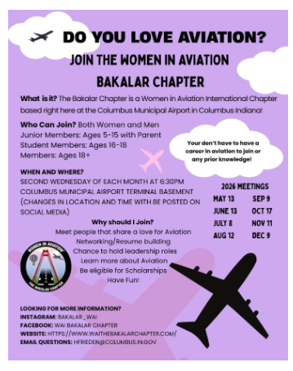
Opportunities
Interested in being involved with Women in Aviation? Join in on the fun with the Bakalar chapter at any of their meetings this year…
Upcoming meeting:
Saturday, June 13th, 10:30-12:30
Meet at 9:30am at Columbus Airport for carpool or meet us there at provided address:
1035 A Ave., Seymour, IN 47274
Museum and Airport/Terminal tour with lunch at Lola’s Modern Kitchen afterwards (not provided) and must RSVP a week in advance for lunch!

