SAFETY TOPIC: The Takeoff Briefing
Hello everyone! This is Kate Russell writing your newsletters now, which means in addition to all of the relevant information John Tunell writes up for me…you will now get that lovely KR commentary!
What a great first topic John has chosen, by far one of the most important if not THE most important piece of any flight. Takeoff is one of the shortest phases of flight, yet it carries some of the highest workload and risk with approximately 25% of general aviation accidents occurring during takeoff and initial climb specifically. A disciplined takeoff briefing helps ensure you are prepared for what comes ahead in one of the most critical phases of flight.
I always try to emphasize to my students, if you were to catastrophically lose an engine or control in the takeoff segment, you are only going to have 3-40 seconds (or less) before you are on the ground. It is going to take an initial shock factor of at least 7 seconds to recognize and diagnose a problem and another probably 5 to decide and figure out what you are going to do. A targeted and SPECIFIC takeoff briefing eliminates that decision making process and gives you more time to execute a plan and make it to the ground safely.
A takeoff briefing should include all of the following if not more:
- Departure Runway
  - What is the runway number you are departing from? Will you be turning Left or Right on departure? Does your Magnetic Compass and Heading Indicator look correct?
- Type of Takeoff
  - Normal? Short field? Soft field? A combination? I always advise if it is an abnormal takeoff that you brief specifically how to execute it.
- Runway Length
- Takeoff Length
  - Using performance data, what is a visible point on the runway or surrounding area that you can use to say…”If I am not off by ______” I will be aborting the takeoff. If your aircraft can take off in 900ft and you’ve rolled 3500ft or have rolled well past takeoff speed…something is wrong.
- Wind Direction
  - Is this a left or right crosswind? Tailwind?
- Wake Turbulence Potential
- Other Hazards
  - Is my airplane really heavy? Could frost have developed on my wings? Are there any obstacles in the departure path? Have birds or other wildlife been reported?
- Emergency Plan
  - Loss of power, directional control, or fear the airplane will not fly during takeoff roll
  - Loss of power, directional control, or fear the airplane will not fly during initial climb up to 500 feet AGL
  - Loss of power, directional control, or fear the airplane will not fly during initial climb above feet AGL
- Positive Exchange of controls (or who is doing what) in the event you have multiple pilots
  - This is especially important when you are in a training environment or even a flight review or recreational flight with an instructor or other experienced pilot. Make sure everyone in the plane knows who will fly and be in control of the emergency.
- Any Questions anyone has
The emergency plan is the most important part of the brief and I always encourage everyone to be VERY specific with their plan. I notice a lot of pilots will be pretty specific up until 500 feet and then when they are above that just say “above that we will turn wherever is feasible”. Eliminate that decision from the process. Be familiar with the surrounding terrain, intersecting runways, etc. and decide on the ground while you have time what you will do! Here is my full script for a takeoff briefing and you can find more insight and information by visiting https://midwestflyer.com/the-basics-of-flying-takeoff-briefing/ [Article by Dean Zakos, published in Midwest Flyer Magazine.]

Departure Runway
Type of Takeoff
Runway Length
Takeoff Length
…if not off by ________________ we will pull power to idol and reject takeoff
Actual Wind Direction
…we will have L/R crosswind
Wake Turbulence Potential
Other Hazards

In case of Emergency…
If we encounter loss of power, loss of directional control, or we fear the airplane will not fly…
- On the takeoff roll we will pull power to idol and reject takeoff
If we encounter the same issues on the initial climb up to 500feet (agl)
- We will push the yoke forward, feel light in our seat, and land straight ahead or left or right +/- 30 deg
Above 500ft agl
… If intersecting runways:
- We will push the yoke forward, feel light in our seat, and will turn L/R to land on ___ runway
… If only one runway:
- We will push the yoke forward, feel light in our seat, and can turn anywhere we want but WILL NOT return to the departure runway

Positive Exchange of Controls (in the event of an emergency PIC/Instructor will take controls and PIC/instructor will do checklists)
Any Questions?

CHAPTER NEWS:

2026 Young Eagles Schedule Announced
Mark your calendars! We are excited to announce our 2026 Young Eagles Rally dates.
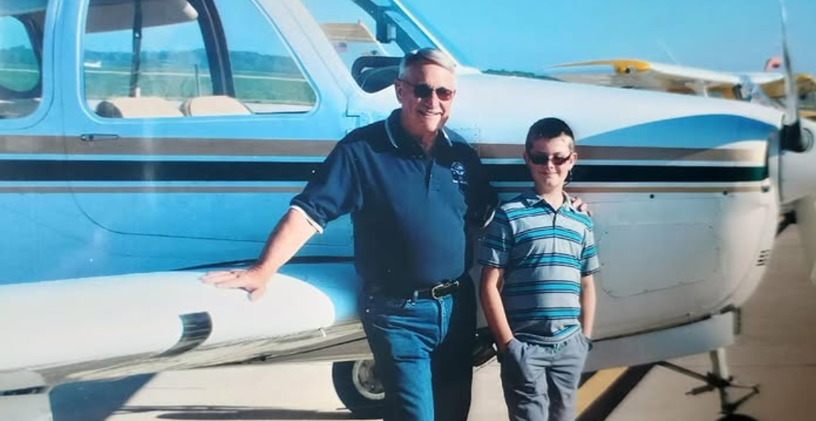
These FREE airplane rides give young people the opportunity to experience the magic of flight firsthand. 2026 Young Eagles Rally Dates:
- May 9, 2026
- June 13, 2026
- August 8, 2026
- September 19, 2026
- October 17 (tbd)
Each rally runs from 9:00 AM to 1:00 PM, with registration opening one month prior to each event. Flight reservations can be made at http://eaachapters.org. Follow the calendar at eaa729.org and our social media (@eaachapter729 on Facebook and Instagram) for updates!
If you are interested in volunteering with the Young Eagles Program either as a pilot or ground volunteer, please visit Young Eagles Resources for Chapters and Volunteer Pilots| EAA AirVenture Oshkosh for more information and contact Ryan Malanoski rkmalanoski@gmail.com to get started!

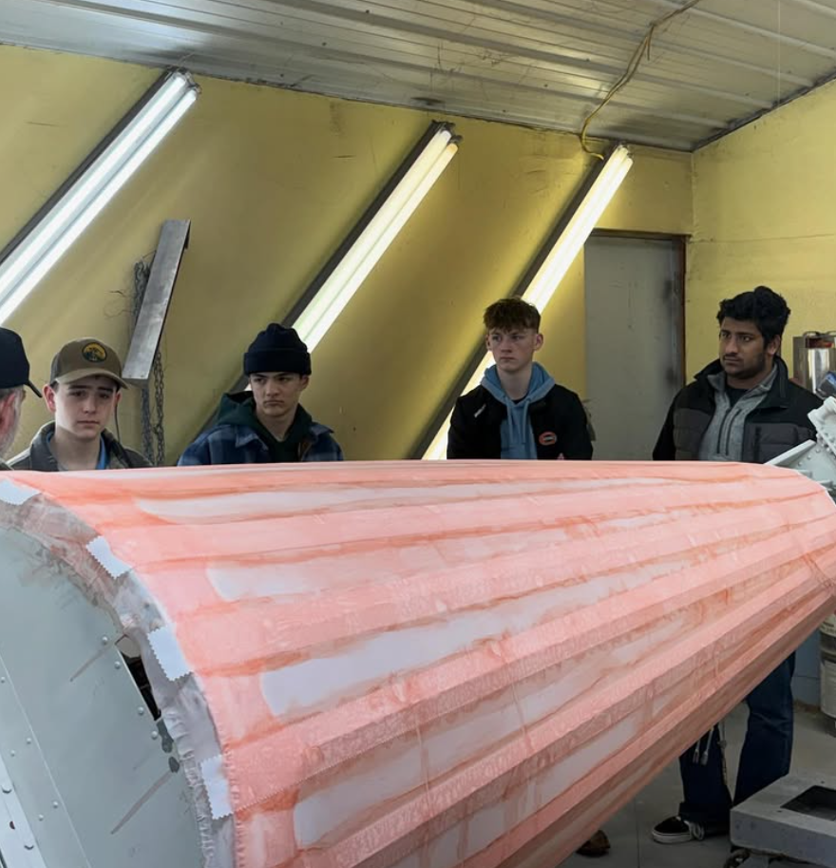
Youth and Adult Build Updates
Youth Zenith 650 Build Progress
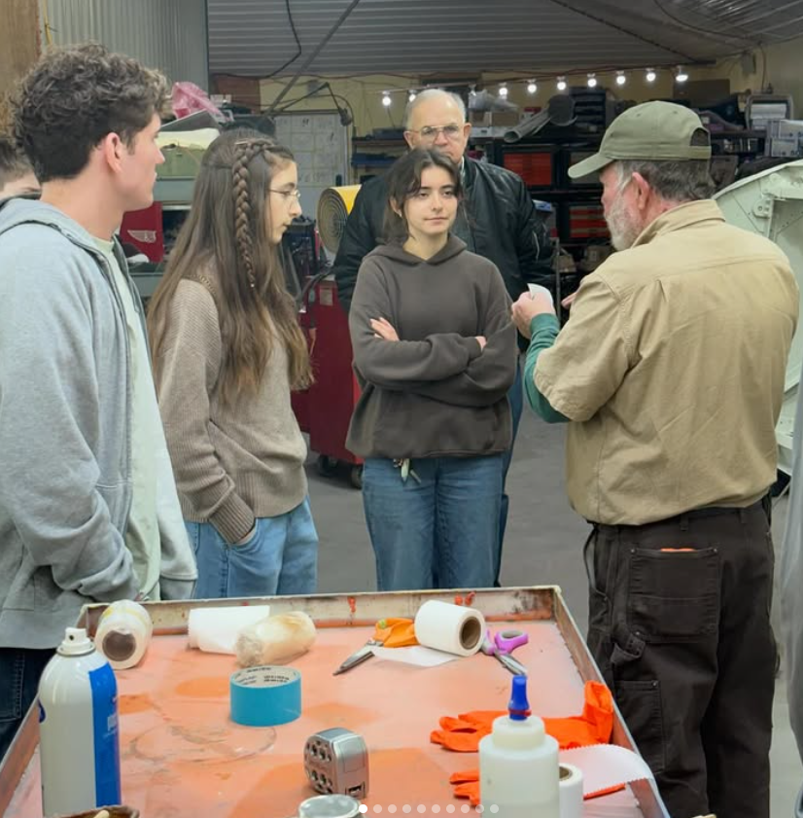
February has been a productive month for our youth build team despite winter weather challenges! The team pushed through piles of ice and snow to continue work on the wing skins, making impressive progress on installing stringers between the ribs. A significant milestone was reached when the team began installing replacement nose ribs for the left Zenith wing assembly. As often happens in aircraft building, they discovered a dimensional issue with the first set of ribs (they had been miss-cut😬). But as our mentors reminded everyone, mistakes are part of the learning process, and working through challenges like these provides invaluable real-world experience.
The highlight of the month was a special field trip to Mike Williams’ shop, where students learned about the process of covering an airframe with fabric. The hands-on demonstration gave our youth builders exposure to a critical skill in aircraft construction and restoration. A second group of students also visited Mike’s workshop to observe the process of skinning an N3N aircraft, broadening their understanding of different construction techniques.
These educational opportunities beyond our own hangar are invaluable for showing students the full spectrum of aircraft building and maintenance work.

<<< Image features 2025 Ray Scholar, Ethan Paul (Left)

Adult Zenith Build Sessions
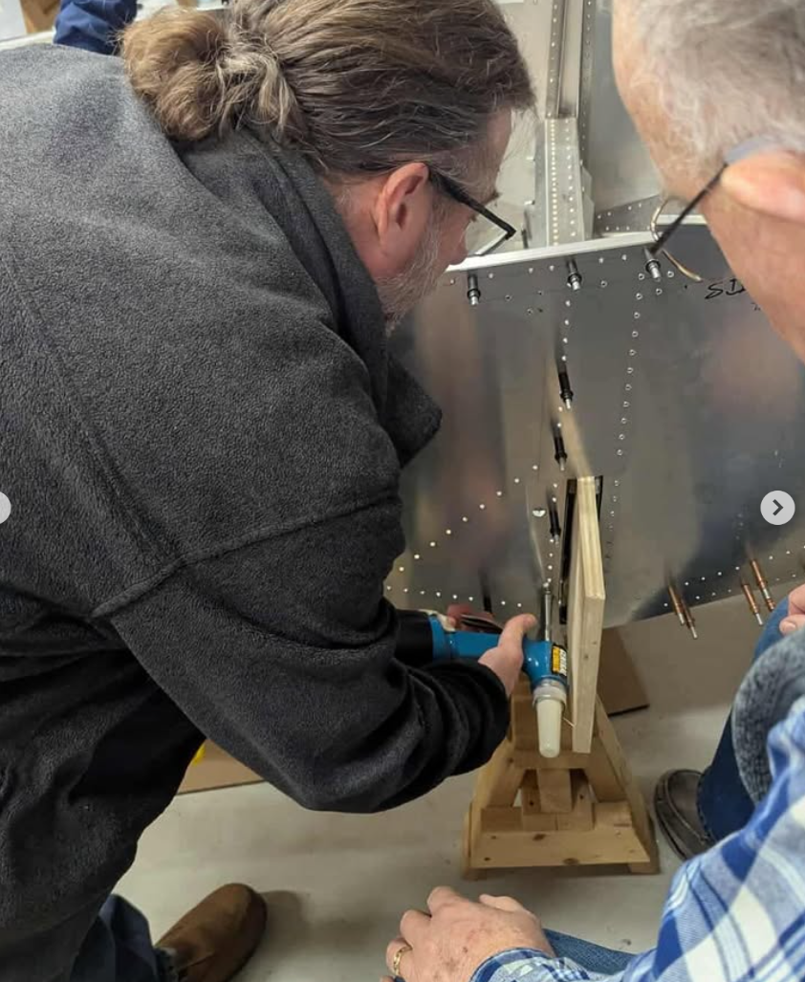
The adult build team continues making excellent progress on the fuselage during their Wednesday evening sessions. Many subassemblies have been completed or are nearing completion and waiting to come together. The team also enjoyed a productive rivet pulling party, bringing multiple components closer to final assembly.
We’re excited to announce that we’ll be ordering the firewall forward kit very soon which is another major step toward completion!
Every Wednesday from 6-8 PM, adult chapter members gather to collaborate on the Zenith fuselage build. The teamwork and shared expertise make these sessions both productive and enjoyable.
For real-time updates and behind-the-scenes moments from both build projects, follow us on Facebook at facebook.com/eaa729 and on Instagram at instagram.com/eaachapter729.

Exciting New Option: Lifetime Membership
We’re thrilled to announce a new opportunity for Chapter 729 members—a Lifetime Membership for a one-time investment of $500. This isn’t just a membership upgrade; it’s a smart investment that benefits both you and the chapter for years to come.
When you purchase a lifetime membership, the full $500 goes directly into the EAA Chapter 729 Heritage Fund. The Heritage Fund returns approximately 4-5% of the principal to EAA 729 annually (roughly equivalent to typical yearly dues). The remaining interest is folded back into the fund, allowing your investment to grow over time.
What’s Included:
- Lifetime chapter membership dues (no more annual renewals!)
- Your contribution grows in the Heritage Fund
- The chapter receives ongoing annual support from your investment
- (top secret information but I have heard rumors of a complimentary T-shirt)
*Important Note: The lifetime membership covers chapter dues only and does not include simulator access. Lifetime members who wish to use the simulator will still need to purchase the annual simulator membership separately.
The lifetime membership option will be available on our website at https://eaa729.org/shop/ in late February.
Have questions about the Heritage Fund and how it works? Reach out to Bill Batten, John Tunell, or Brad Stinebring for more information.

Friendly Reminder: 2026 Chapter Dues
As we continue through another exciting year, we kindly remind all EAA 729 members to submit their 2026 chapter dues. Your continued support helps cover essential expenses like hangar maintenance and the food we all enjoy during our gatherings. Every dollar you contribute goes directly back into benefiting the chapter and its members.
Not sure of your current status? Reach out to Bill Batten, he will be happy to help. Thank you for being a vital part of our aviation family!

Volunteer Opportunity: Help with Youth Zenith 650 Build
We are looking for volunteers with mechanical aptitude and a passion for aviation to help mentor the next generation of aviation enthusiasts as they build a Zenith 650! If you have experience in aircraft construction, mechanics, or simply enjoy working with young people in the aviation community, we would love to have you on board. This is a fantastic opportunity to share your knowledge, inspire future pilots, and make a lasting impact on the lives of these young builders. If you’re interested in volunteering, please reach out directly to Brad Stinebring or James Yrineo for more details.

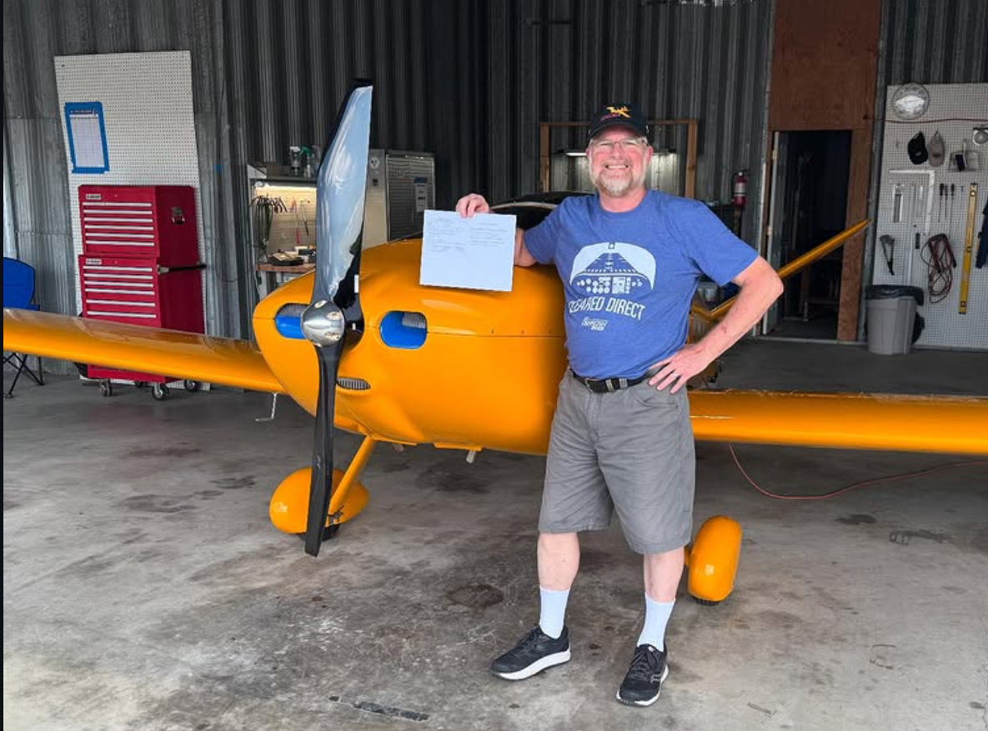
Share Your Aviation Story!
We want to hear from you! Chapter 729 is always looking for member-contributed content to feature in our monthly newsletter. Whether you’ve achieved a new rating, reached a building milestone, completed an interesting flight, or have an aviation story to share, we’d love to include it.
We’re looking for aviation achievements and milestones, personal aircraft build project updates, interesting flying experiences or trips, aviation-related articles or insights, and photos from your aviation adventures.

How to Submit: Send your stories, articles, or photos to John Tunell at jtunell.av8r@gmail.com. Help us celebrate the diverse aviation experiences within our chapter community!


Upcoming Chapter Events and Gatherings
February Chili Cook-Off
Thursday, February 19th at 6:00 PM
EAA Chapter 729 Hangar – KBAK
Bring the heat! Join us for our 3rd Annual Chili Cook-Off. Whether you have a signature chili recipe that’s been a hit for years, or you’re experimenting with new flavors, bring your best pot of chili (or side/dessert) and show us what you’ve got!
How it works: Come hungry and vote for your favorite chili by placing a donation in the cup next to the pot. The chili with the most donations wins the coveted title of Best Chili in Town—and, of course, bragging rights!
This event is going to be BIG. We hope to see you, your family, and friends eager to eat some chili on Thursday night!

March Monthly Gathering
Thursday, March 19th at 6:00 PM
EAA Chapter 729 Hangar – KBAK
Join us for our March gathering featuring a presentation by Bill Batten titled “Yes - Your Flight Instructor Lied to You!” This promises to be an eye-opening and entertaining discussion that will challenge what you think you know about flying. Don’t miss it!

CONTACTS AND LINKS:
Website: eaa729.org
Facebook: facebook.com/eaa729
Instagram: instagram.com/eaachapter729.

Board + Committee Contacts

John Tunell (President) - jtunell.av8r@gmail.com
Kate Russell (Vice President) - cbuskate@gmail.com
Bill Batten (Treasurer) - williamabatten@gmail.com
Larry Kelly (Secretary) - lostaviator@gmail.com
Ryan Malanoski (Y.E. Coordinator) - rkmalanoski@gmail.com
James Yrineo - jfyrineo@gmail.com
Kyle Smith - mister.meow@icloud.com
Jason Tepool - jasontepool@gmail.com
Noah Shatto - gonefishingaway@gmail.com
Dan Villiger - dan.villiger@sbcglobal.net
Mike Foushee - michaelfoushee@yahoo.com
Brad Stinebring - blstinebring@comcast.net

EAA & AOPA Airshow Schedules
AOPA Events - https://www.aopa.org/news-and-media/news-by-topic/events/airshow
EAA Events - https://www.eaa.org/eaa/events

