SAFETY TOPIC: Builder Safety
Happy May now! I hope everyone is excited for the upcoming *hopefully warmer weather and to finally not have to look at a bunch of dead fields…instead looking at many beautiful green fields!
With all the homebuilding activity the board suggested I blab about making sure you are safe whilst building your hopefully extremely safe airplanes.
During your builds, try to make sure you are not working in a poorly ventilated space, especially when using epoxies, solvents, or doing any composite work. Opening a door, running a fan, or wearing a respirator when needed is a simple fix, and it is one of those things that is easy to overlook until it catches up with you.
If you are working alone, let someone know where you are and what you are doing. A quick text before starting gives you a backup plan if something unexpected happens.
For anything heavy or awkward, it is probably worth asking for help. A second set of hands makes moving wings, engines, or large components much safer and helps avoid both injury and damage. A lot of these parts are not necessarily heavy, just difficult to handle, which is usually where problems start.
Keeping the workspace reasonably organized also goes a long way. Tools and scrap build up quickly, and that is usually when something gets dropped or you trip over something that should not have been there. Taking a minute here and there to reset the space makes everything easier.
And then just sticking with the basics. Safety glasses, gloves, hearing protection. Easy to skip for a quick task, but those are usually the ones that cause problems.
It is easy to focus on building a safe airplane, but that process goes a lot better when you guys make sure to keep yourselves safe too!

Your CFI LIED to you!
Thank you to everyone who joined us at Bill Batten’s presentation in March, “Your CFI LIED to you!”. Bill debunked the “myths” around flying lean of peak. Here are some takeaways from Bill himself:
- Running lean of peak does not hurt your engine*
- However, to run lean of peak, you need modern EGT/CHT instrumentation and must either confirm that you have excellent cylinder to cylinder mixture distribution - or, be running port fuel injection
- If you don't have both of these features - then you need to be running rich of peak- just like your CFI taught you
For those of you not overly familiar with “flying lean of peak”... flying lean-of-peak(LOP) refers to running the engine’s mixture control so that the exhaust gas temperature (EGT) is below its peak value. At peak EGT, the engine is burning all the fuel entering the cylinder; beyond that point, further leaning reduces EGT and power. LOP settings use a leaner fuel/air mix, which lowers cylinder head temperatures (CHTs) and fuel burn rates. However, extreme leanness without proper monitoring and engine capability can cause overheating, detonation, and long-term engine damage.
Always follow your POH and engine manual, and avoid leaning beyond safe limits.

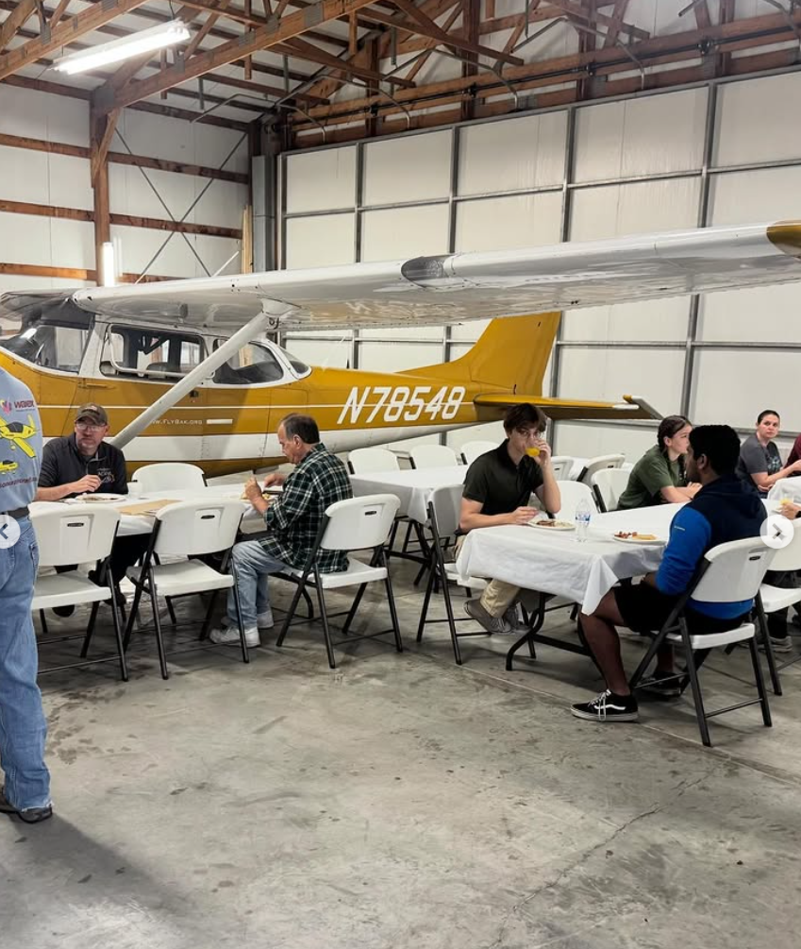
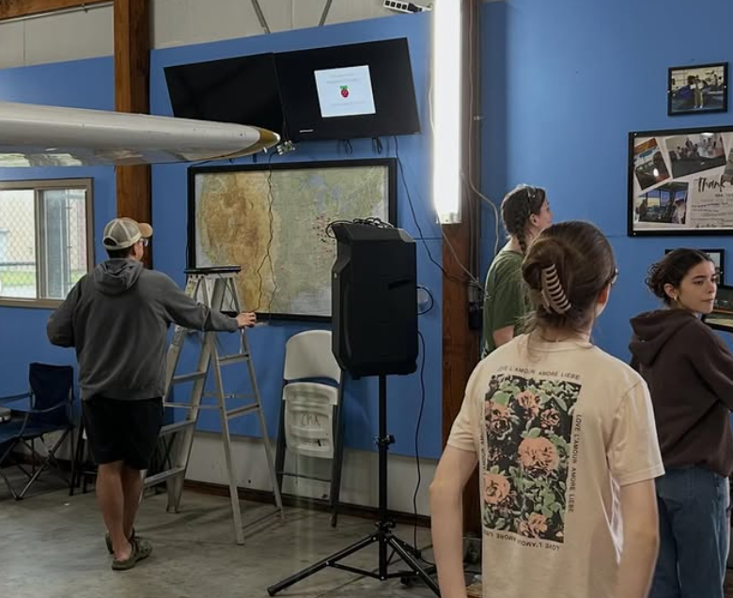
April Hangar Cleanup
Thank you to everyone who came out, ate breakfast, and helped square away the hangar for the spring and summer months!
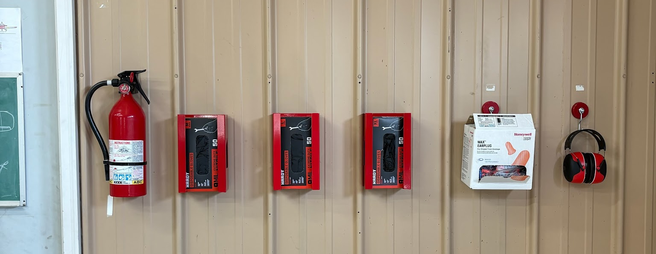
We worked on organizing some tools, inspecting and restocking safety materials like gloves, fire extinguishers, and more. Additionally, we have the photo TV up and working! Stay tuned for how to upload photos and share your adventures!

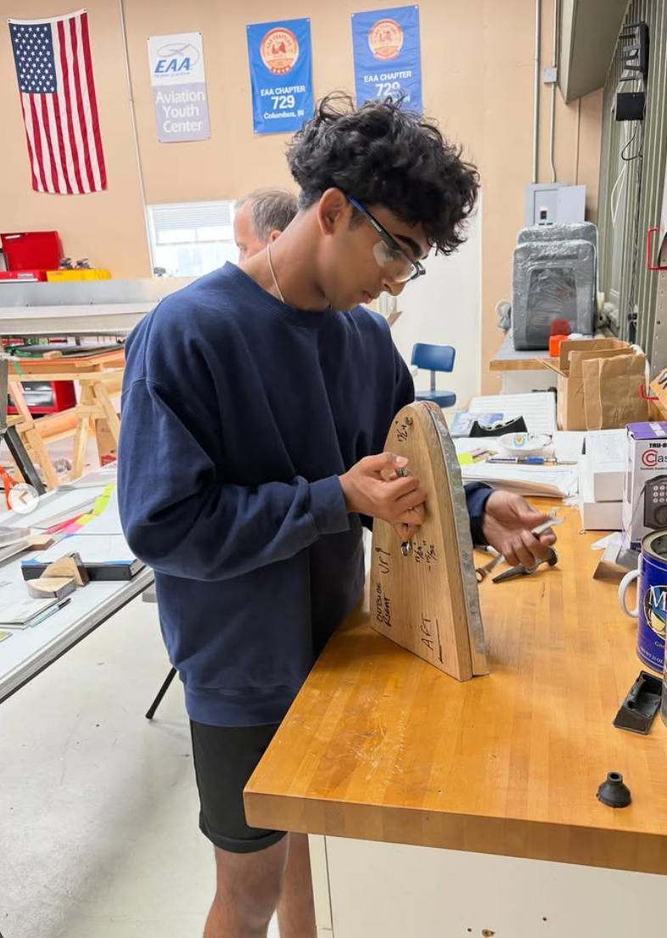
Youth and Adult Build Updates
Youth Zenith 650 Build Progress
After the local Spring Break, the youth are back and hard at work on the Zenith build. Progress has been strong as they begin laying out the wing lockers. They have started the cutting process and are gaining hands-on experience with precision work, including filing edges, squaring components, and ensuring proper fit and finish. Once the wing locker components are completed and ready for installation, the team will shift focus back to installing the fuel tanks, marking the next major step in the aircraft assembly process.
Adult Zenith Build Sessions
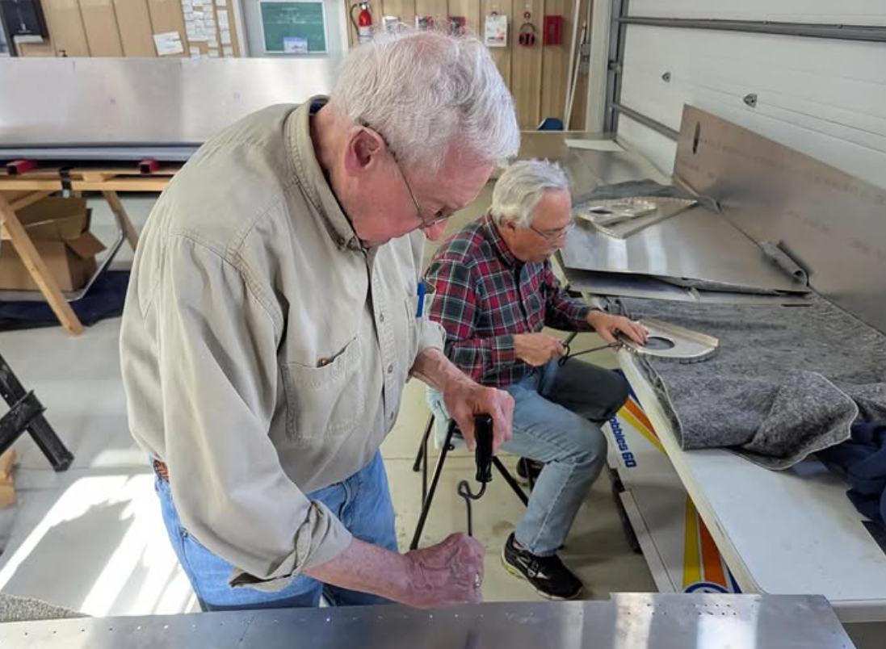
The focus for the adults is still on riveting the fuselage and preparing the turtle deck assembly. Last I had heard…we have ordered the firewall forward kit and just the other day paid the shipping fee! Looking forward to seeing that part of the plane come together throughout the rest of the year.
For real-time updates and behind-the-scenes moments from both build projects, follow us on Facebook at facebook.com/eaa729 and on Instagram at instagram.com/eaachapter729.

Volunteer Opportunity: Help with Youth Zenith 650 Build
We are looking for volunteers with mechanical aptitude and a passion for aviation to help mentor the next generation of aviation enthusiasts as they build a Zenith 650! If you have experience in aircraft construction, mechanics, or simply enjoy working with young people in the aviation community, we would love to have you on board. This is a fantastic opportunity to share your knowledge, inspire future pilots, and make a lasting impact on the lives of these young builders. If you’re interested in volunteering, please reach out directly to Brad Stinebring or James Yrineo for more details.

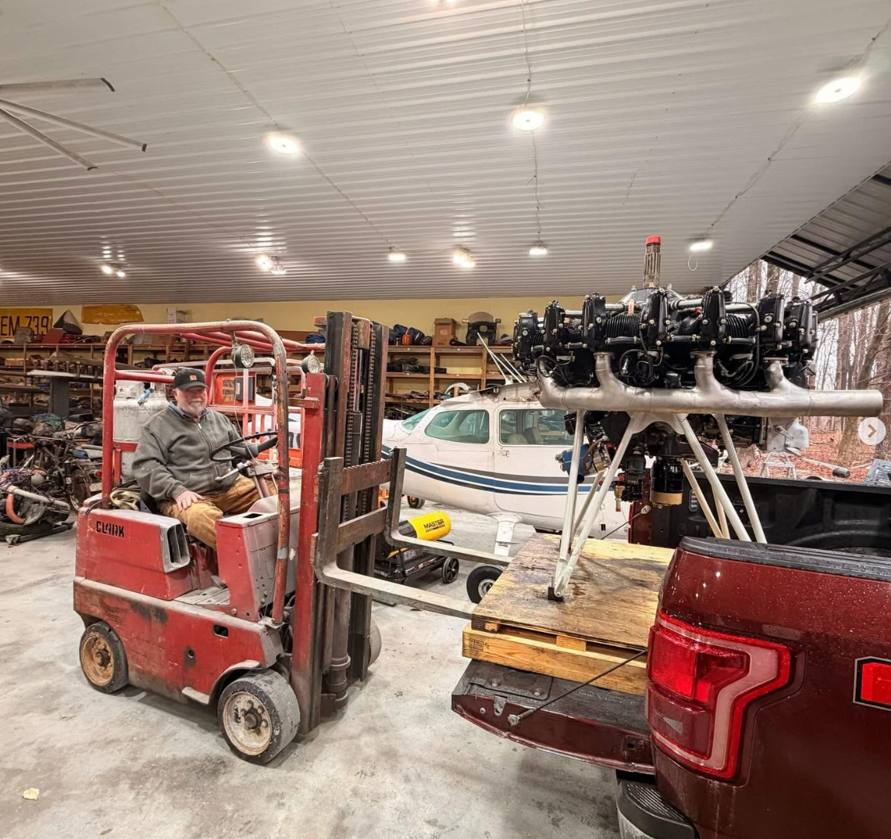
New Engines!
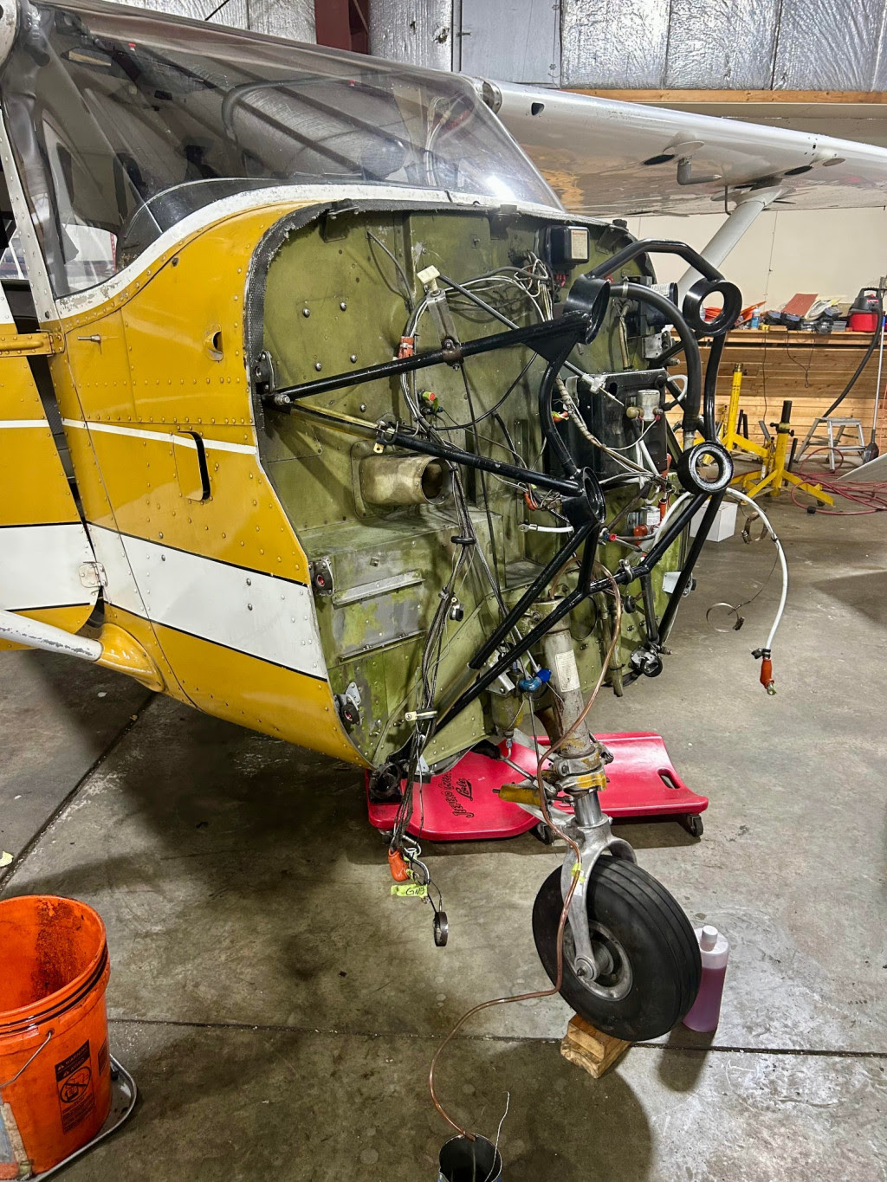
There has been a lot of engine excitement throughout the chapter as of recently! Firstly, we recently got our first look at a Lycoming R-680 radial engine, which will eventually help power Brad Stinebring’s N3N restoration. The youth took a field trip out to Mike William’s shop to help unload the R-680 and had a chance to check it out up close. We also picked up a donated Continental A-65 engine for our Youth Program! Over the next few weeks, we’ll go through the A-65, inventory its parts, and get it ready to sell. The funds from that sale will go directly back into supporting our Youth Program.
Additionally, the firewall forward and engine kit has been ordered for the Zenith as aforementioned!
For many EAA members, their local flight club (FlyBAK) Cessna 172 recently went through an engine swap and has just finished up the break in phase! We have all missed Matilda and we are excited to see it come back!

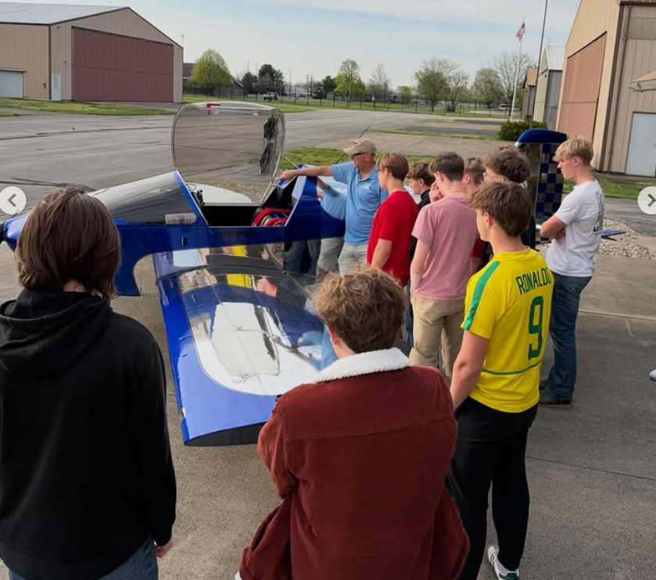
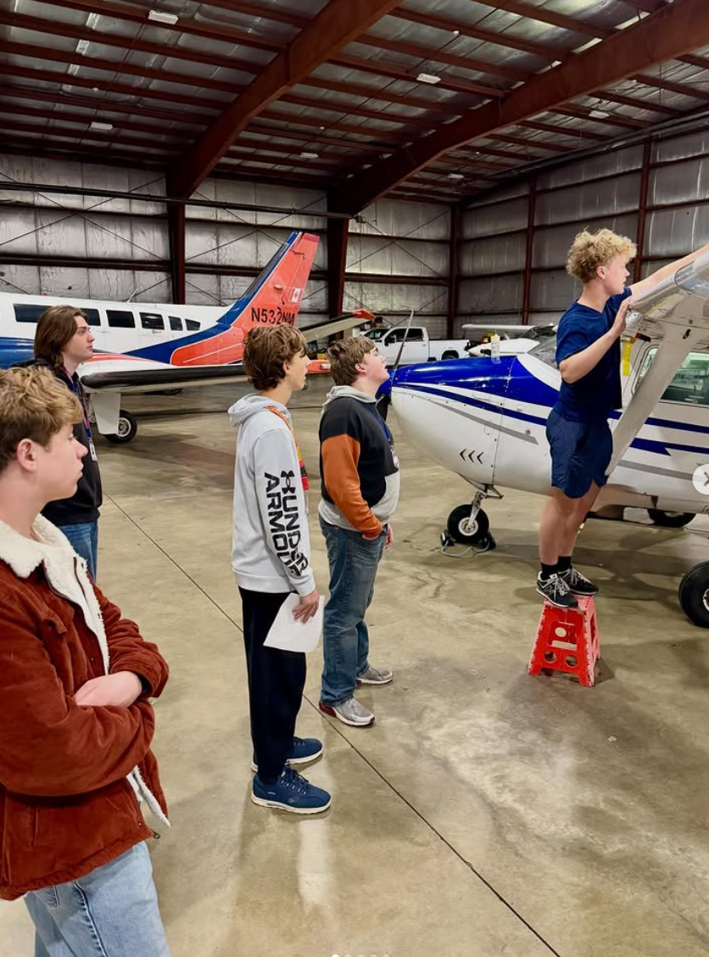
Hangar Visits!
On Friday, April 10th, Ryan Malanoski hosted 28 students from the Martinsville High School aviation class at our hangar. James Yrineo displayed his Sonex for the students to explore and spoke to them about chapter activities and the youth center. Ryan also arranged for the students to visit the museum, the C-119, the control tower, and tour the airport as a whole.
The students learned about checklists and how to properly preflight an aircraft. The day wrapped up with information about the different organizations on the field and the scholarships available through each. Matt Medley also spoke, sharing information about Ivy Tech and Lift Academy.

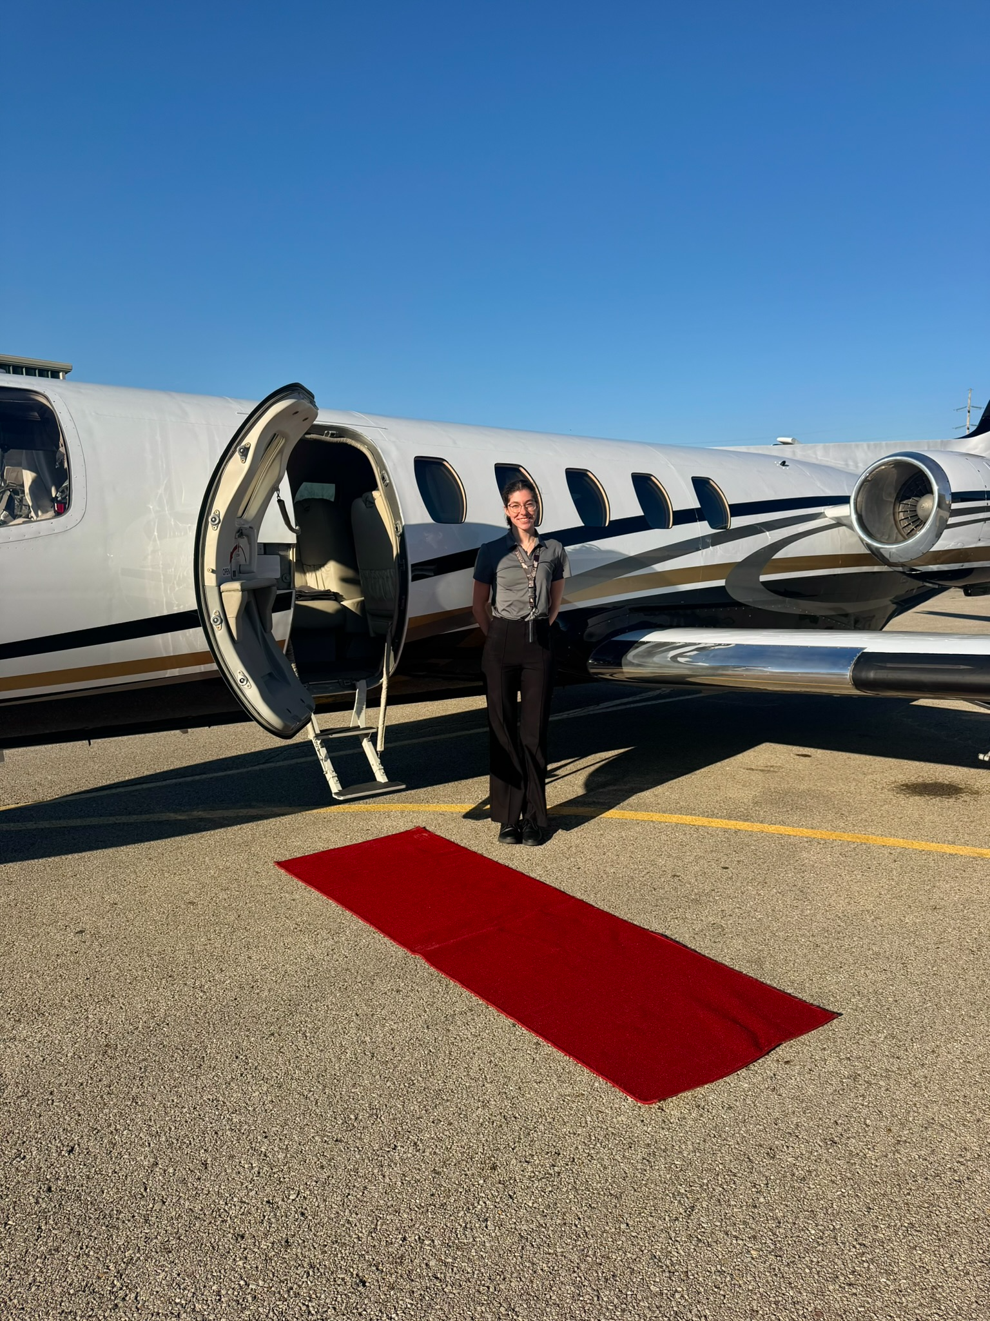
Member Minute: Kate Russell
SUBMIT YOUR ACCOMPLISHMENTS PLEASE! We want to hear from you and share what you have been up to!
I have been busy jetting around the country! I now have an SIC type rating in the Citation 500 series, which basically means I can fight on the radios with Miami Approach and touch the flap lever. Jokes aside, I am really enjoying the opportunity to learn and fly at a more professional level, and I am excited to see where this goes.
Brad Stinebring always says my jet flying does not count toward putting a pin on the “Where have you flown this year?” map in the hangar, but I personally beg to differ.
Recently, I have been down to Marathon in the Florida Keys multiple times, as well as spending quite a bit of time in Miami. Additionally, I was down in John Tune last week.

REMINDERS:

Upcoming Chapter Events and Gatherings
*THE MAY MONTHLY MEETING IS NOT AT THE EAA CHAPTER 729 HANGAR*
May Monthly Gathering
Thursday, May 21st at 6:30 PM
Freeman Army Airfield Museum – 1035 A Ave., Seymour, IN 47274
This May we are going to meet down at Freeman Flying Field for a tour of the Museum from EAA 729s very own Larry Boothe!
June Monthly Gathering
Thursday, June 18th at 6:30 PM
EAA 729 Hangar - 4750 Kelly St Columbus, IN 47203
The June Monthly Meeting Focus will be an annual “Builder Updates” event where we will meet to discuss many of our builders' progress and offer insight or just moral support!

2026 Young Eagles Schedule… YOUNG EAGLES STARTS MAY 9TH
Our first Young Eagles event of the year is this coming Sunday, May 9th! Registration is currently full and we are starting a waitlist…it can be joined here: https://eaachapters.org/event-details/YE2551P3T
Each rally runs from 9:00 AM to 1:00 PM, with registration opening one month prior to each event. Flight reservations can be made at http://eaachapters.org. Follow the calendar at eaa729.org and our social media (@eaachapter729 on Facebook and Instagram) for updates!

If you are interested in volunteering with the Young Eagles Program either as a pilot or ground volunteer, please visit Young Eagles Resources for Chapters and Volunteer Pilots| EAA AirVenture Oshkosh for more information and contact Ryan Malanoski rkmalanoski@gmail.com to get started!
2026 Young Eagles Rally dates:
- May 9, 2026
- June 13, 2026
- August 8, 2026
- September 19, 2026
- October 17 (tbd)

Friendly Reminder: 2026 Chapter Dues
As we continue through another exciting year, we kindly remind all EAA 729 members to submit their 2026 chapter dues. Your continued support helps cover essential expenses like hangar maintenance and the food we all enjoy during our gatherings. Every dollar you contribute goes directly back into benefiting the chapter and its members.
Not sure of your current status? Reach out to Bill Batten, he will be happy to help. Thank you for being a vital part of our aviation family!

Submit Your Accomplishments and Updates!
We want to hear from you! Chapter 729 is always looking for member-contributed content to feature in our monthly newsletter. Whether you’ve achieved a new rating, reached a building milestone, completed an interesting flight, or have an aviation story to share, we’d love to include it.
We’re looking for aviation achievements and milestones, personal aircraft build project updates, interesting flying experiences or trips, aviation-related articles or insights, and photos from your aviation adventures.
How to Submit: Send your stories, articles, or photos to John Tunell at jtunell.av8r@gmail.com. Help us celebrate the diverse aviation experiences within our chapter community!

CONTACTS/LINKS/SCHOLARSHIPS/ETC.:
Website: eaa729.org
Facebook: facebook.com/eaa729
Instagram: instagram.com/eaachapter729.

Board + Committee Contacts

John Tunell (President) - jtunell.av8r@gmail.com
Kate Russell (Vice President) - cbuskate@gmail.com
Bill Batten (Treasurer) - williamabatten@gmail.com
Larry Kelly (Secretary) - lostaviator@gmail.com
Ryan Malanoski (Y.E. Coordinator) - rkmalanoski@gmail.com
James Yrineo - jfyrineo@gmail.com
Kyle Smith - mister.meow@icloud.com
Jason Tepool - jasontepool@gmail.com
Noah Shatto - gonefishingaway@gmail.com
Dan Villiger - dan.villiger@sbcglobal.net
Mike Foushee - michaelfoushee@yahoo.com
Brad Stinebring - blstinebring@comcast.net

EAA & AOPA Airshow Schedules
AOPA Events - https://www.aopa.org/news-and-media/news-by-topic/events/airshow
EAA Events - https://www.eaa.org/eaa/events
Scholarships
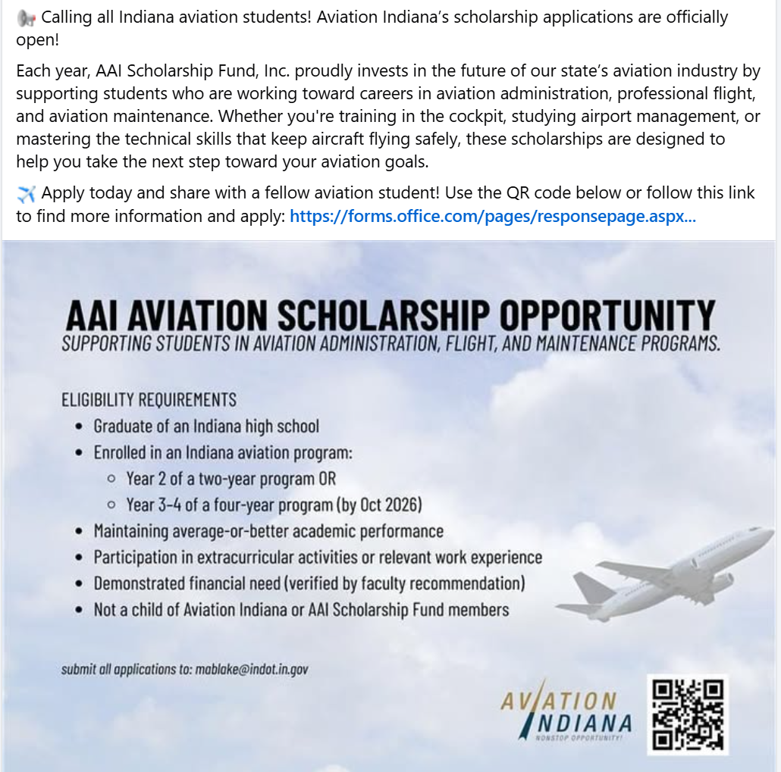
AAI Aviation Scholarship Form
Opportunities

